Q SKILLS INTRO LS VOCABULARY UNIT 1 Answer Key

Exercise 1:

Player ........1........... Cycling ...........9.........
Musician ........5......... Painting .........10..........
Conversation .....3..... Chart ...........6.............
Field ............8........... Week ...........7.............
Soccer ...........4........ Lake ............2.............
Exercise 2: Complete the sentences by using the words above.
- My favorite sport is .............soccer................
- He is a very good football ............player....................
- She plays the guitar well. She is a professional ..........musician..........
- The .......conversation.............. between the teacher and the student was useful.
- We went to the .........lake.......... at the weekend.
- What are your travel plans for the next .......week......... ?
- This .......painting.............. belongs to Vincent van Gogh.
- You can see the results in the ..........chart............
- You can grow vegetables in this .........field................
- Let’s go .........cycling................... this weekend.

Q SKILLS INTRO LS VOCABULARY UNIT 2 Answer Key
Exercise 1:
VERB | SENTENCE
BEGIN | We ......watch.............. television every evening.
COME | ........Give.............. me one more chance
END | Can you........come.................. with us?
THANK | I need to ......talk......... to you.
WALK | I think his contract will ............end......... this year.
WATCH | I ......miss........... him so much.
GIVE | They .........learn......... Russian at school.
HAVE | It .......stopped.......... raining. Let’s go for a walk.
LEARN | He ..........walks........... two miles to work every morning.
LIVE | I always ......help........... my mother with housework.
SWIM | The meeting didn’t ..........begin ...... at nine.
TALK | We need to ......study....... hard to pass this exam.
WORK | ......Thanks.............. you for helping us.
MISS | I couldn’t ........sleep............ last night.
HELP | He .....works........... so hard to earn money.
SLEEP | When did you.........start............... learning English?
START | I don’t like to ......swim......... in the pool.
STOP | We usually ........have.............. breakfast at about eight.
STUDY | I hope I ........live........ to see my grandchildren.

Exercise 2:
ADJECTIVE | ANTONYM | SENTENCES
Boring | Enjoyable- Interesting
Different | Same
Difficult- Hard | Easy
Kind | Rude
Correct | Wrong
Happy | Sad

LISTENING BOOK UNIT 3 VOCABULARY REVISION ANSWER KEY
PART 1. Different answers are okay with the pictures.
Example: I have a bowl of cereal for breakfast.
I have a slice of bread and some butter for breakfast.
I drink a glass of milk.
I have a sandwich for lunch.
I have salad.
I have a bowl of soup and some bread for dinner.
PART 2 Match each adjective with its antonym.
Bad X good
Careful X careless
Fast X slow
Funny X boring
Happy X sad
Boring X interesting
Cheap X expensive
Dirty X clean
Different X ordinary
Easy X difficult
Empty X full
Important X unimportant
Light X dark
Safe X dangerous
Dry X wet

Part 3. Fill in the blanks using the verbs in the box.
grow lose try choose mean close want cook

- I helped my sister to choose a name for her baby.
- Lie down and close your eyes.
- Children grow very quickly.
- My sister always loses her car keys.
- The read light means stop.
- My father cooks meat in oil and spices.
- My parents want to buy a new car.
- You are very tired. Try to have some rest.

LISTENING BOOK UNIT 4 VOCABULARY REVISION ANSWER KEY
Exercise 1: Match the words in the box with pictures.
find enjoy know ride teach show love paste relax

  RELAX/ENJOY |   KNOW | 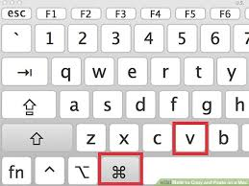  PASTE |   RELAX/ENJOY
  LOVE | FIND   |   RIDE | 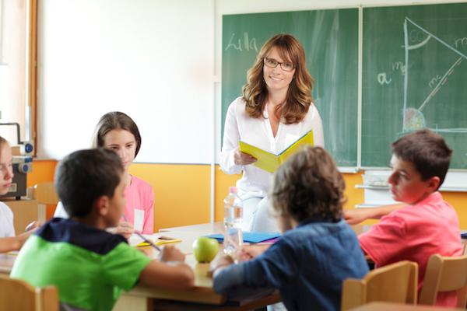  TEACH
SHOW


Exercise 2: Complete the sentences by using the word in the box. There are more words than you need.
find field enjoy know lake player ride teach show love paste relax complete exciting famous friendly great lazy conversation musician

- You should stop listening to my telephone CONVERSATIONS .
- The famous jazz MUSICIAN was a composer and a pianist.
- Did you FIND the door key?
- Each PLAYER takes three cards.
- Our neighbours are very FRIENDLY to us.
- We TEACH English to foreign students.
- They SHOWED the painting to everyone in the galery.
- You need to COMPLETE the application form.
- That’s EXCITING/GREAT news. I am so happy.
- The daughter is learning to RIDE .
- Cut that paragraph and PASTE it at the end of the page.
- I feel depressed. Nothing seems EXCITING to me.
- Get out of the bed. You are so LAZY .
- We went boating on that LAKE .

ANSWER KEY
UNIT 5 – WHAT MAKES A GOOD HOME
Part A. Fill in the blanks in the picture with the words in the box. There is ONE EXTRA word.
living room kitchen hall garage bathroom garden bedroom pool

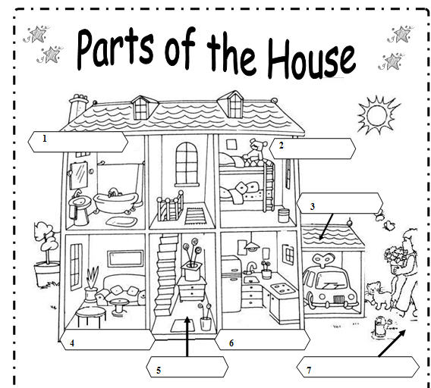

bathroom
bedroom

garage

kitchen
living room
hall
garden

Part B. Look at the picture above and fill in the blanks.
- There is a car in the garage.
- There is a teddy in the bedroom.
- There are two butterflies in the garden.
- There are two pillows in the living room.
- There is a fridge in the kitchen.
- There is a mirror in the bathroom.

Part C. Look at the picture and fill in the blanks using the prepositions in the box.
above in front of upstairs below next to between behind downstairs on under in (x 8)

- There is a coffee table in front of the armchair in the living room.
- There are three pillows on the bed in the bedroom.
- There is a sink next to the fridge in the kitchen.
- There is a living room downstairs.
- There is an armchair behind the coffe table in the living room.
- There is a small bathroom upstairs.
- There is a plant between the window and the armchair in the living room.
- There is a dustbin below the window in the bedroom.
- There is a mirror above the sink in the bathroom.
- The child is working under the sun in the garden.
Part D. Circle the correct answer.
- I live in a small _______ in German.
- door b. city c. bottle d. season
- The classroom is _____________. Students can’t hear the teacher.
a. silent b. noisy c. messy d. Perfect
- Jane’s house has a good _____. It is near stores and restaurants.
- bank b. location c. grammar d. child

- A good home has a big swimming ______.
- pool b. officer c. hotel d. gardener

- A good bed is ______.
- noisy b. false c. selfish d. comfortable

- My apartment is noisy , but it is _____ coffee shops and supermarkets.
- upstairs b. near c. downstairs d. at

- There is a baby in the room, so you can’t ______ here.
- remember b. smoke c. see d. like

- Jack and Lisa want to ______ a beach house in Çeşme this summer.
- pay b. draw c. rent d. Describe

LISTENING BOOK UNIT 6 VOCABULARY REVISION ANSWER KEY

UNIT 6 HEALTHY LIFE HABITS

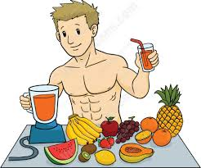
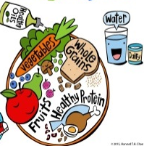
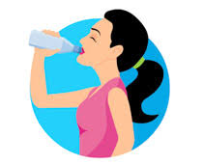
A. Proper Nutrition
take vitamins
eat vegetables and fruit
have a healthy diet
drink more water

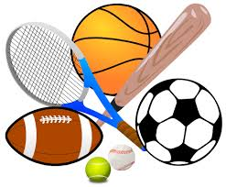
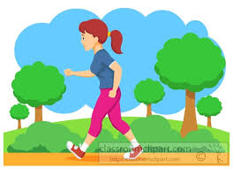
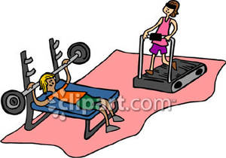

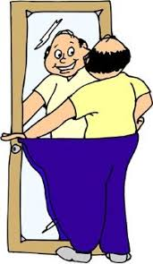
Physical Activity
exercise regularly /have good exercise habits

go jogging/go running /go for a walk
do sports regularly
lose weight
go to the gym

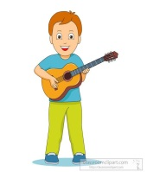


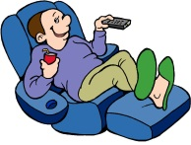
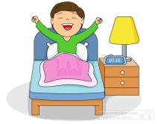
Rest & Hobby
get enough sleep/sleep well
read books
go shopping
play an instrument
take a rest

B. Fill in the blanks using the correct form of the word in the box.
law
- Jane wants to be a lawyer.
interest
- I am not interested in running.
feeling
- My brother feels very happy after doing sports.
manager
- His parents manage a gym in Antalya.
excited
- Football is a very exciting sport.

C. regulary prepare healthy sick

- exercise ____regulary__________
- ______prepare________ your own food
- eat ______healthy________
- feel ______sick________
UNIT 7 and UNIT 8 PERIOD 1 Q SKILLS INTRO LISTENING AND SPEAKING COURSE
ANSWER KEY

- Choose the word which matches the definition.

- Find information, a place or an object, especially for the first time

- Retire
- Discover
- Create

- To cause something to get better.

- Improve
- Correct
- Locate

- A formal talk on a serious subject given to a group of people, especially students.

- Culture
- Lecture
- Correction

- The general weather conditions of a particular place.

- Climate
- Location
- Opportunity

- A very tall modern building, usually in a city.

- Monument
- Architect
- Skyscraper

- What you can see from a particular place.

- Resident
- View
- Genius

- Written artistic works

- Literature
- Distance
- Politics

- To leave your job or stop working because of old age or ill health.

- Graduate
- Retire
- Discover

- A long printed story about imaginary characters and events.

- Star
- Universe
- Novel

- Very great and rare natural ability or skill.

- Lecturer
- Genius
- Astronomer

- Fill in the blanks with one of the words in the box

astronomer distance get a job get better

recent graduate(d) various average

brightness get in touch lecturer climate

- Please wait. We will ___GET IN TOUCH_____________ with you shortly.

- He taught design for several years as a part-time ___LECTURER__________ .

- House prices have risen in ___RECENT____________ years.

- What’s the ___DISTANCE________ between Ankara and İstanbul?

- She ____GRADUATED__________ from university last year.

- There are ____VARIOUS__________ types of restaurants in this town.

- An ____ASTRONOMER______________ observes stars, planets, moons, comets and galaxies.

- To __GET A JOB___________ quickly you need to write a full CV.

- I liked the _____BRIGHTNESS____________ of the colours in this room.

- The Mediterranean ___CLIMATE________ is good for growing citrus fruits and grapes.

- Her English and French ____GET BETTER______________ every year.

- In a/an ____AVERAGE___________ week I drive about 50 km.

- Choose the correct form of the words

- The lights are too ___________ in here- they’re hurting my eyes.
BRIGHT – BRIGHTNESS
- You can win a car when you answer ______________ .

CORRECT/ CORRECTLY

- The hotel is in a beautiful _____________________ .

LOCATED/LOCATION

- After ______________, she wants to travel around Europe.

GRADUATE/ GRADUATION

- I am cooking something _________________ for her birthday.

SPECIAL/SPECIALIZE

